DATE: 19.04.2019
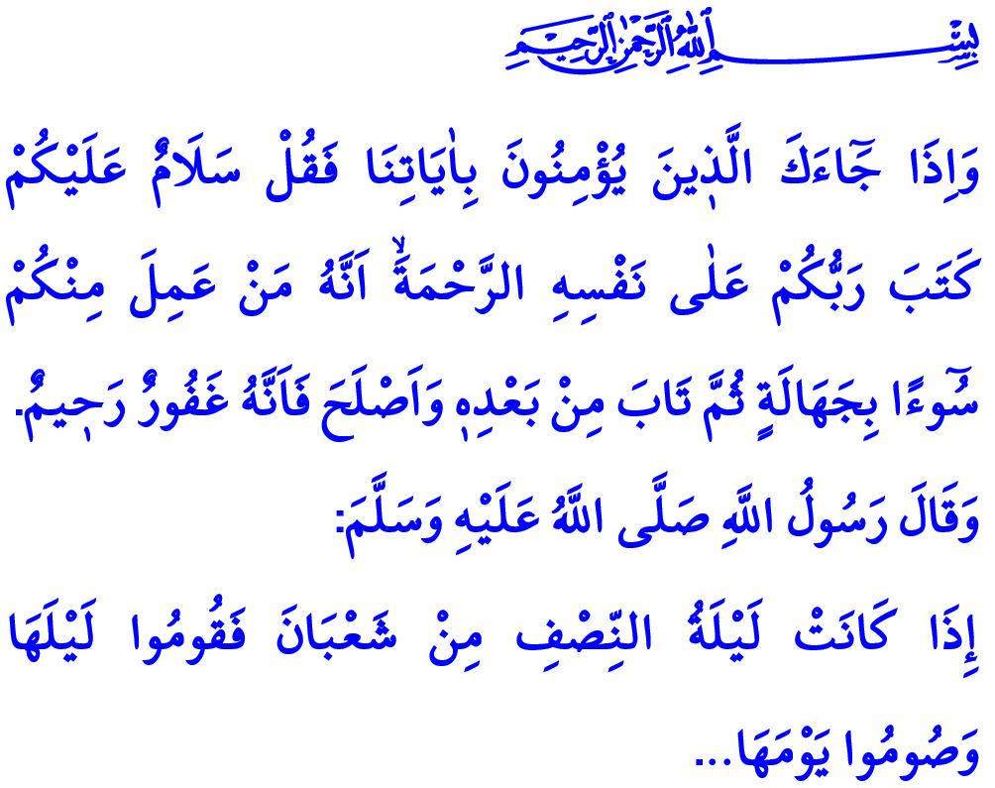
LAILAT AL-BARA’AH
Dear Muslims!
Time is one of the greatest blessings granted by the Almighty Allah (swt) to His servants. Time is a field of possibilities and opportunities which surrounds a man's life story entirely. Therefore, it is a unique wealth, every moment of which is precious and worthy of spending well. The ones who value and do not waste their time and the ones who are subject to the guidance of the Messenger of Allah (saw) by pursuing Allah’s (swt) consent at every stage of their lives are going to be honoured with the gift of the Almighty Allah (swt). Wasting time is the biggest loss and the biggest frustration for a man.
Honorable Believers!
Regardless of any specific month, day or hour, every moment of ours spent with the awareness of servitude to Allah (swt) is valuable. But there are certain times that are bestowed as the times of divine grace and are conduced to the acceptance of prays and the absolution. These periods of time are signs of the infinite mercy of Allah (swt) on the people. Here is the Lailat al-Bara’ah that we shall comprehend this evening, it is one of such valuable times.
Dear Muslims!
The sacred months of Rajab and Shaban prepare us for the month of Ramadan, both spiritually and physically. The first one, the month of Rajab, is blessed with Lailat al-Ragaib and Lailat al-Mi’raj. The middle one, the month of Shaban, leads to forgiveness and mercy by means of Lailat al-Bara’ah. The Messenger of Allah (saw) gave us the glad tidings that the worship, pray, and entreaty to be performed on Lailat al-Bara’ah are going to conduce to our absolution by saying, “Spend the fifteenth day of the month of Shaban by observing a fast. And its night in prayer. Because, when the sun sets at that night, Allah Ta’ala manifests Himself at the nearest heaven in a state which we cannot know of, and until the time of dawn He says, ‘Is there nobody asking for forgiveness? Forgive I shall! Is there nobody asking for sustenance? Sustenance I shall give him! Is there nobody suffering a calamity? Felicity I shall give him!…”
Honorable Believers!

Lailat al-Bara’ah is a time to open a path towards al-Rahman (swt) from the deepest part of our hearts. Lailat al-Bara’ah is high time for us to repent and seek Allah’s (swt) mercy and forgiveness by turning to Him.

The most basic requirement of benefitting from this blessed night is to get ourselves away from the turmoil of life a bit and question our servitudes. It is to ask ourselves the questions of ‘What I am busy with, which goal do I live for, and where do my intentions and deeds bring me to?’ It is to turn to our inner world, review our past, and contemplate. It is to promise the Almighty Allah (swt) to be an obedient servant and a good person. It is to ensure redemption from the cravings of our nafs and to repent of our mistakes and sins. Then, tonight is going to turn into an opportunity in real sense for us and salvation is going to be our bara’ah. Thus, the Almighty Allah (swt) states in the Holy Qur’an by addressing to the Prophet Muhammad (saw), “When those come to thee who believe in Our Signs, say: ‘’Peace be on you; Your Lord hath inscribed for Himself (the rule of) mercy: verily, if any of you did evil in ignorance, and thereafter repented, and amended (His conduct), lo! He is Oft-Forgiving, Most Merciful.’”
Dear Believers!

Let us benefit from the teaching and barakah (abundance) of this night to receive the bara’ah of salvation in eternal life. Let us pursue Allah’s (swt) consent in each breath. Let us shape our lives according to the guidance of the Qur’an and the Sunnah. Let us remember that every moment of ours that we do not spend with the awareness of servitude to Allah (swt) is going to return to us as damage and loss.

With this occasion, I would like to congratulate your Lailat al-Bara’ah. May the Almighty Allah (swt) let this holy night bring prosperity to our noble nation, to the Islam world and to all humanity.

Ibn Majah, Iqamat, 191.
An’am 6/54. Directorate General of Religious Services

